3 day State Level training programme on "Gender Budgeting in Policing" sponsored by ministry of Women and Child development, Government of India at Hotel Chandra Inn, Jodhpur from 16.3.2017 to 18.3.2017.
The training programme on “Gender Budgeting in Policing” in Jodhpur was a landmark event on university’s accounts. The workshop, for the first time, brought together Police Personnel, Account Officers, Academicians and NGO’s upon several issues influencing Gender Budgeting. The Workshop developed a consensus on the need to allocate funds so as to improve the position of women, hence contributing to gender equality. Various dimensions related to Gender Budgeting were explored through multiple views of resource persons and participants. Power point presentations and various activities were carried out to explain gender budgeting in detail. Presentations, including case studies, illustrated the need for gender budgeting which can be right tool for gender equality and women’s empowerment and strengthening country ownership over development. . Thus, the Conference became successful because of the contribution of many including resource persons and police personnel.
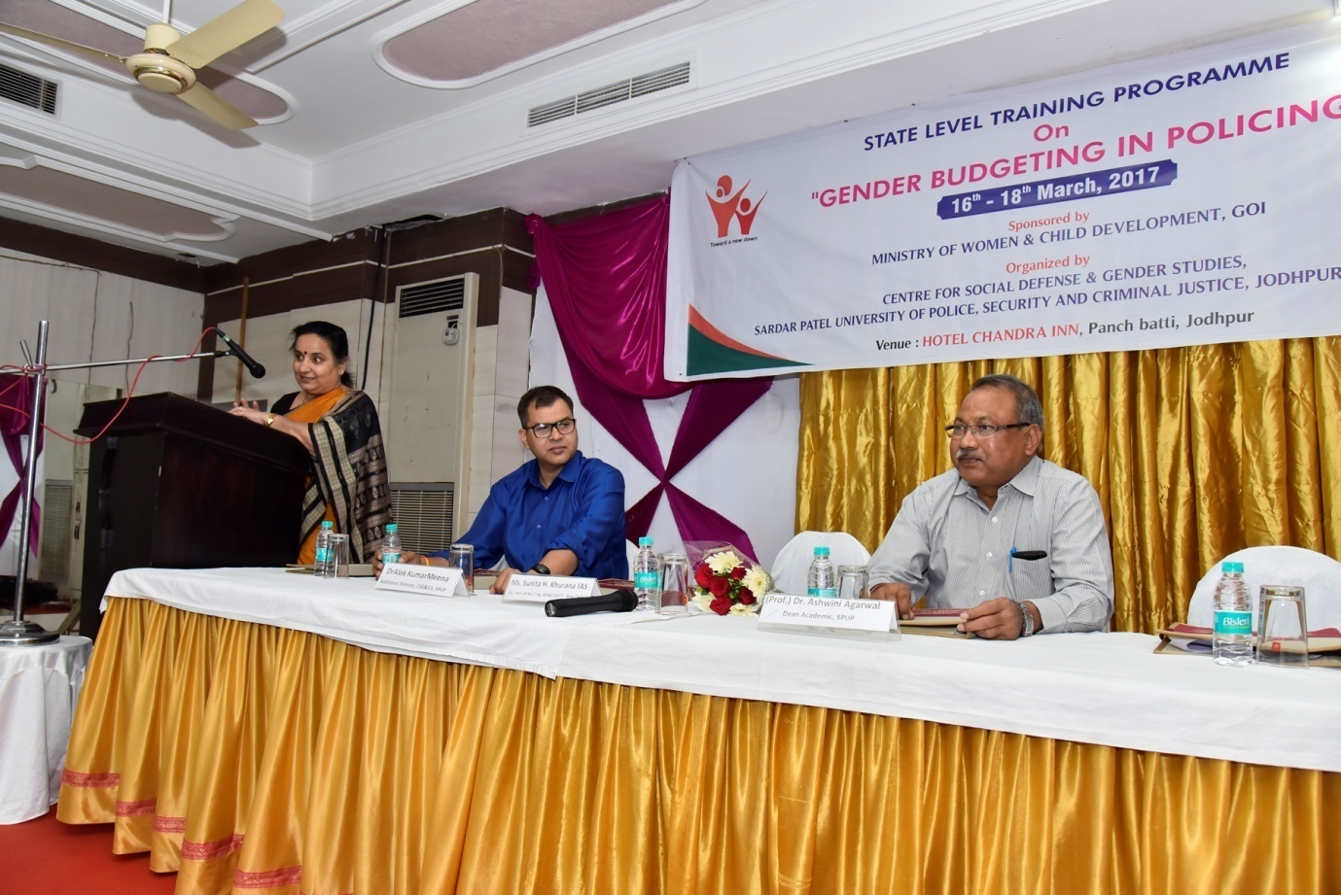

3 days District Level training programme “Gender Budgeting in Policing” sponsored by ministry of Women and Child development, Government of India at Chandra Inn, Jodhpur from 6th to 8th March 2017.
Gender Budgeting is a powerful tool for achieving gender mainstreaming so as to ensure that benefits of development reach women as much as men. It is not an accounting exercise but an ongoing process of keeping a gender perspective in policy/ program formulation, its implementation and review. GB entails dissection of the Government budgets to establish its gender differential impacts and to ensure that gender commitments are translated in to budgetary commitments. Pushing for more women in police forces, the Union Ministry of Home Affairs has advised to introduce ‘gender budgeting’ in allocation of police funds to provide ample facilities and equipment for women police personnel in the state.
Police personnel of the rank of Additional SP, Dy.SP, Inspectors, SubInspectors, ASI, Head Constable, Constable, Accountants /OAs, NGOs from District level to be involved in three days training programme.
